**TRAIN ACCIDENT PREVENTION**

**Major Project Stage – 1 Report**

***Submitted in partial fulfillment of the requirements for the award of the Degree of***

**Bachelor of Technology (B.Tech)**

**in**

**COMPUTER SCIENCE AND ENGINEERING(IoT)**

**By**

**M.Poojitha-20AG1A6935**

**M.Maneesh-20AG1A6933**

**P.Santhosh-20AG1A6950**

**N.Vijay kumar yadav -20AG1A6945**

**Under the Esteemed Guidance of**

**Mrs E.Uma Rani(Assistant professor)**



**Department of Computer Science and Engineering**

**ACE ENGINEERING COLLEGE**

**An AUTONOMOUS Institution**

**NBA Accredited B. Tech Courses, Accorded NAAC ‘A’ Grade**

**(Affiliated to Jawaharlal Nehru Technological University, Hyderabad, Telangana)**

**Ankushapur (V), Ghatkesar (M), Hyderabad - 501 301.**

**December 2023**

**TRAIN ACCIDENT PREVENTION**

**Major Project Stage-1 Report**

***Submitted in partial fulfillment of the requirements for the award of the Degree of***

**Bachelor of Technology (B.Tech)**

**in**

**COMPUTER SCIENCE AND ENGINEERING(IoT)**

**By**

**M.Poojitha-20AG1A6935**

**M.Maneesh-20AG1A6933**

**P.Santhosh-20AG1A6950**

**N.Vijay kumar yadav-20AG1A6945**

**Under the Esteemed Guidance of**

**Mrs E.Uma Rani(Assistant professor)**



**Department of Computer Science and Engineering**

**ACE ENGINEERING COLLEGE**

**An AUTONOMOUS Institution**

**NBA Accredited B. Tech Courses, Accorded NAAC ‘A’ Grade**

**(Affiliated to Jawaharlal Nehru Technological University, Hyderabad, Telangana)**

**Ankushapur (V), Ghatkesar (M), Medchal – Malkajgiri Dist - 501 301.**

**December – 2023**

**ACE**

**Engineering College**

**An AUTONOMOUS Institution**

**Website: [www.aceec.ac.in](http://www.aceec.ac.in) E-mail: [info@aceec.ac.in](mailto:info@aceec.ac.in)**

**DEPARTMENT OF COMPUTER SCIENCE AND ENGINEERING**

**CERTIFICATE**

This is to certify that the Major project stage-1 work entitled **“TRAIN ACCIDENT PREVENTION ”** is being submitted by **M.Poojitha(20AG1A6935), M.Maneesh(20AG1A6933),P.Santhosh(20AG1A6950),**

**N.Vijay kumar yadav (20AG1A6945)** in partial fulfillment for the award of Degree of **BACHELOR OF TECHNOLOGY** in **COMPUTER SCIENCE AND ENGINEERING(IoT)** to the Jawaharlal Nehru Technological University, Hyderabad during the academic year 2023-24 is a record of bonafide work carried out by them under our guidance and supervision.

The results embodied in this report have not been submitted by the student to any other University or Institution for the award of any degree or diploma.

**Internal Guide Head of the Department**

**Mrs E.Uma Rani Dr.M.V.Vijaya Saradhi**

**Assistant Professor Professor and Head**

**Dept. of CSE(IoT)**

**Project Coordinator**

**Mrs Pethota Swaroopa**

**Assistant Professor EXTERNAL EXAMINER**

**ACKNOWLEDGEMENT**

I would like to express my gratitude to all the people behind the screen who have helped me transform an idea into a real time application.

I would like to express my heart-felt gratitude to my parents without whom I would not have been privileged to achieve and fulfill my dreams.

A special thanks to our General Secretary, **Prof. Y. V. Gopala Krishna Murthy,** for having founded such an esteemed institution. Sincere thanks to our Joint Secretary **Mrs. M.Padmavathi**, for support in doing project work. I am also grateful to our beloved principal, **Dr. B. L. RAJU** for permitting us to carry out this project.

I profoundly thank **Dr. M. V. Vijaya Saradhi**, Professor and Head of the Department of Computer Science and Engineering, who has been an excellent guide and also a great source of inspiration to my work.

I extremely thank **Mrs.Pethota Swaroopa**, Assistant Professor, Project coordinator, who helped us in all the way in fulfilling of all aspects in completion of our Major-Project.

I am very thankful to my internal guide **Mrs. E. UmaRan**i, Assistant Professor, who has been an excellent and also given continuous support for the Completion of my project work.

The satisfaction and euphoria that accompany the successful completion of the task would be great, but incomplete without the mention of the people who made it possible, whose constant guidance and encouragement crown all the efforts with success. In this context, I would like to thank all the other staff members, both teaching and non-teaching, who have extended their timely help and eased my task.

**M.Poojitha-20AG1A6935**

**M.Maneesh-20AG1A6933**

**P.Santhosh-20AG1A6950**

**N.Vijay-20AG1A6945**

**ABSTRACT**

The Automatic Railway Gate Control System using Arduino, IR sensors, servo motors, LED's, and a buzzer is designed to enhance railway crossing safety by automating gate operations. The system employs two IR sensors as "eyes" to detect the presence of a train. An Arduino Nano serves as the control unit, orchestrating the actions of two servo motors responsible for opening and closing the railway gate. The system uses red and yellow LED's, along with a buzzer, to provide visual and audible indications of the gate's status. Upon detection of a train by IR sensor-1, the gate closes, accompanied by the activation of a red LED and the buzzer. Subsequently, when the train passes and is detected by IR sensor-2, the gate opens, with the yellow LED illuminating and the buzzer ceasing. If neither sensor detects a train, the gate remains open with the yellow LED indicating the idle state. The project aims to mitigate the risks associated with railway crossings, reducing accidents and enhancing overall safety. The components, wiring, and Arduino code collectively form a reliable and precise system that can be implemented to improve railway infrastructure security. The integration of PCBWay.com for PCB prototypes ensures the efficient fabrication of high-quality circuit boards for the successful realization of this Automatic Railway Gate Control System.

**INDEX**

|  |  |  |
| --- | --- | --- |
| **S. NO** | **CONTENTS** | **PAGE. NO** |
| 1. | INTRODUCTION | 1 |
| 2. | LITERATURE SURVEY | 2 |
| 3. | SOFTWARE REQUIREMENT AND ANALYSIS | 5 |
|  | 3. 1 EXISTING SYSTEM | 5 |
|  | 1. 2 DISADVANTAGES | 5 |
|  | 3.3 PROPOSED SYSTEM | 6 |
|  | 3.4 ADVANTAGES | 7 |
|  | 3.5 MODULES AND FUNCTIONALITIES | 9 |
| 4 | SOFTWARE DESIGN | 10 |
|  | 4.1 SYSTEM ARCHITECTURE | 10 |
|  | 4. 2 CIRCUIT DIAGRAM | 11 |
|  | 4.3 BLOCK DIAGRAM | 12 |
|  | 4.4 FLOW CHART | 12 |
|  | 4.5 UML DIAGRAM | 13 |
|  | 4.5.1 CLASS DIAGRAM | 13 |
|  | 4.5.2 ACTIVITY DIAGRAM | 14 |
| 5. | SOFTWARE AND HARDWARE REQUIREMENTS | 15 |
|  | 5.1 HARDWARE REQUIREMENT | 15 |
|  | 5.2 SOFTWARE REQUIREMENT | 17 |
| 7. | REFERENCES | 19 |

**LIST OF FIGURES**

|  |  |  |
| --- | --- | --- |
| **FIG. NO.** | **FIGURE NAME** | **PAGE NO.** |
| 3. 3. 1 | First gate open | 6 |
| 3.3.2 | Gate closed | 6 |
| 3.3.3 | Second Gate open | 7 |
| 4.1 | Architecture diagram | 10 |
| 4.2 | Circuit diagram | 11 |
| 4.3 | Block diagram | 12 |
| 4.4 | Flow chart | 12 |
| 4.5.1 | Class diagram | 13 |
| 4.5.2 | Activity diagram | 14 |
| 5.1.1 | Arduino Nano | 15 |
| 5.1.2 | Servo motor | 15 |
| 5.1.3 | IR Sensor module | 16 |
| 5.1.4 | Buzzer | 16 |
| 5.1.5 | LED | 17 |
| 5.1.6 | Battery | 17 |
| 5.1.7 | Toggle | 17 |
| 5.2.1 | Arduino IDE | 18 |
| 5.2.2 | Getting started with Arduino | 18 |

1. **INTRODUCTION**

The Automatic Railway Gate Control System using Arduino, IR sensors, servo motors, LEDs, and a buzzer represents an innovative application of modern technology to enhance railway crossing safety. With thousands of accidents occurring annually at railway crossings leading to tragic consequences, the imperative for a reliable and automated gate control system becomes evident. This project employs a combination of IR sensors to detect train positions, Arduino microcontroller for intelligent decision-making, servo motors for precise gate control, and visual/auditory indicators such as LEDs and a buzzer to signal the gate's status.

The fundamental concept revolves around the creation of a self-operating gate system that responds dynamically to the presence or absence of a train. Two IR sensors act as the "eyes" of the project, detecting the train's position and triggering the corresponding actions. The Arduino microcontroller serves as the project's "brain," interpreting sensor data and orchestrating the movements of servo motors to open or close the railway crossing gate. The integration of LEDs and a buzzer provides real-time feedback, signaling the system's actions and alerting nearby individuals.

This project not only addresses the critical issue of railway crossing accidents but also serves as a practical application of microcontroller technology and sensor integration. The provided methodology outlines a systematic approach, from the initial design and component integration to coding, testing, documentation, and collaboration with the project sponsor, PCBWay.com, for high-quality PCB prototypes. The ultimate goal is to contribute to a safer and more efficient railway infrastructure by reducing the reliance on manual gate operation and minimizing the potential for human error.

**2.LITERATURE SURVEY**

1. The paper aims to address the issue of train accidents caused by obstacles on railway tracks, specifically focusing on animals and landslides in the context of Indian railways. The authors propose an Internet of Things (IoT) and sensor-based system called TAPS (Train Accident Prevention System). The system involves the use of sensors such as piezoelectric and PIR sensors, along with an Arduino UNO micro-controller and Node MCU for connectivity.
2. The paper introduces an "Advanced Railway Accident Prevention System" using IR sensors, Zigbee, and micro-controllers to enhance railway safety. Features include automatic speed control, collision and fire detection, and railway gate control. The system demonstrates effective obstacle and curve detection, with a claimed accident reduction of about 70%, making it a promising safety solution.
3. The paper discusses the development of an Accident Prevention System for railway tracks in India using deep learning. Employing TensorFlow Lite on a Raspberry Pi with a camera, the system detects obstacles like humans or vehicles on tracks, providing real-time alerts to loco-pilots. The study emphasizes the significance of obstacle detection in reducing railway accidents, presenting a comprehensive solution for enhanced safety.
4. The paper reviews existing systems for accident prevention at railway crossings, particularly unmanned crossings in India. Highlighting persistent accidents, it proposes a real-time system using speech recognition to detect train horns, stop audio players, and generate alarms for non-active individuals. Key components include ultrasonic and infrared sensors, GPS/GSM, image processing, and various detection technologies. Drawbacks include sensor sensitivity, cost, network dependency, accuracy in dark conditions, clashes in operation, and weather dependence. The paper emphasizes the need for a comprehensive, practical system to enhance railway safety.
5. The paper explores railway safety with a focus on preventing accidents and suicides. It stresses the importance of analyzing measures to enhance security, especially at level crossings. The study includes a statistical analysis of railway safety from 2010-2012, noting a decrease in significant accidents and fatalities. It highlights accidents involving unauthorized persons and suicides, with a specific model for analyzing trespassing behaviors. The paper categorizes preventative measures into "Technical/Physical" and "Soft" measures, discussing their potential impacts on suicide and trespassing prevention. The conclusion outlines future prospects for enhancing railway safety.
6. The paper discusses the implementation of an Arduino-based safety system for the prevention of railway accidents, focusing on the Addis Ababa Light Rail Transit as a case study. The proposed system employs ultrasonic, rain, and smoke sensors to detect obstacles on the track, flooding, and smoke inside the train, respectively. Through simulation in Proteus, the authors demonstrate the successful detection of these hazards. The system triggers alarms and alerts for train operators in real-time, aiming to prevent accidents by enabling timely corrective actions. The paper concludes that this innovative technology could significantly enhance the reliability of railway safety systems.
7. The paper "Railway Accident Monitoring" addresses the ongoing issue of railway accidents by proposing a module equipped with sensors and microsystems to detect various faults. The key elements include Infrared (IR), Piezo, and Reed sensors, along with an ATmega8 microcontroller. The system aims to identify causes like derailment, anti-collision, wheel imbalance, level crossings, and tunnel accidents. The proposed solutions involve continuous monitoring using sensors, such as IR sensors for detecting defects in tracks and Piezo sensors for anti-collision purposes. The paper emphasizes cost-effectiveness and efficiency, with simulations conducted using tools like Proteus. However, specific performance metrics, real-world testing results, and comparisons with existing systems are not extensively covered in the provided overview. Addressing these aspects could enhance the understanding of the proposed solution's effectiveness.
8. The paper discusses an "Embedded Based Train Accident Prevention System," aiming to prevent train collisions by implementing a multi-component system. The proposed system utilizes IR sensors, ZigBee and RF modules, a PIC microcontroller, and a regulated power supply. Key features include track detection, wireless communication between trains, and emergency braking. However, the paper lacks detailed technical information and real-world testing results. The conclusion emphasizes the system's potential for cost-effective collision avoidance in railways. Suggested improvements include providing more technical details, validation metrics, comparative analysis, scalability considerations, and a comprehensive discussion on power consumption.

**3.SOFTWARE REQUIREMENT ANALYSIS**

**3.1 EXISTING SYSTEM**

Manual lifting railway gates, also known as level crossing gates or broom barriers, are operated by railways staff or gatekeepers to control the passage of vehicles and pedestrians across railway track. Here’s hoe they typically work :

* Detection of Train Approach
* Closing the gates
* Ensuring Safety

It’s important to note that manual lifting railway gates rely heavily on the presence and actions of the gatekeepers. Train operations during rainy conditions can be more challenging and potentially riskier due to reduced visibility, slippery tracks, and other rain- related factors. This causes train accidents.

**3.2 DISADVANTAGES OF EXISTING SYSTEM**

Manual lifting railway gates, while serving their purpose, have several disadvantages:

**Human Error**: Manual operation relies on gatekeepers to raise and lower the gates at the right times. Human error, such as forgetting to close the gate or mistiming the opening, can lead to accidents.

**Response Time**: Gatekeepers might not always be able to respond quickly to approaching trains, especially in situations where multiple trains are coming from different directions simultaneously.

**Labor Intensive**: Manual operation requires dedicated gatekeepers at each level crossing, which can be labor-intensive and expensive to maintain, especially in remote or less populated areas.

**3.3 PROPOSED SYSTEM**

The proposed Automatic Railway Gate Control System outlined in the information above aims to address the existing challenges associated with traditional manual gate control at railway crossings. The system utilizes modern technology, including Arduino microcontrollers, infrared (IR) sensors, servo motors, LEDs, and a buzzer, to create an automated and intelligent gate control mechanism.

Practically, the two IR sensors are placed at left and right side of the railway gate. The distance between the two IR sensors is dependent on the length of the train. In general we have to consider the longest train in that route.

Now we’ll see how this circuit actually works in real time. In this image, we can see the real time representation of this project.

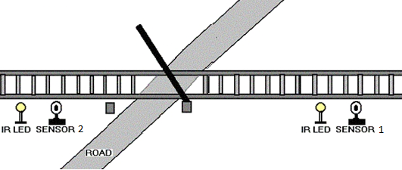

**Fig no. 3.3.1 First Gate open**

If the sensor 1 detects the arrival of the train, microcontroller starts the motor with the help of motor driver in order to close the gate.

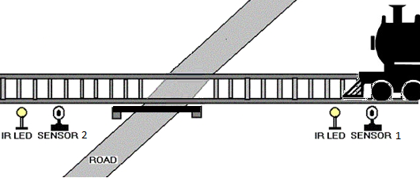

**Fig no. 3.3.2 : Gate closed**

The gate remains closed as the train passes the crossing.

When the train crosses the gate and reaches second sensor, it detects the train and the microcontroller will open the gate.

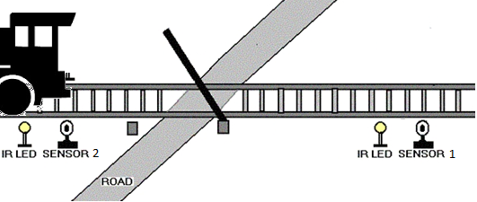

**Fig no. 3.3.3 : Second Gate opened**

**3.4 ADVANTAGES OF PROPOSED SYSTEM**

1. **Automation and Precision:**

**Advantage:** The system automates the gate control process based on real-time detection of trains using infrared sensors. This automation eliminates the need for manual intervention, ensuring precise and timely gate operations.

1. **Reduced Human Error:**

**Advantage**: By minimizing reliance on human operators, the system significantly reduces the potential for human errors in judgment, reaction time, or communication. This enhances overall safety at railway crossings.

1. **Prompt Response to Train Presence:**

**Advantage**: The automated detection system ensures a rapid response to the presence of trains. The gates close promptly when a train is detected, minimizing the risk of accidents caused by delayed gate closure.

1. **Dynamic Gate Control:**

**Advantage**: The system's ability to dynamically control the gates based on train movement improves efficiency. Gates open and close in response to changing conditions, optimizing the flow of traffic at the railway crossing.

1. **Visual and Auditory Indicators:**

**Advantage:** The inclusion of LEDs and a buzzer as indicators enhances situational awareness for both motorists and pedestrians. Clear visual and auditory signals communicate the status of the crossing gates, contributing to safety.

1. **Energy Efficiency:**

**Advantage**: The system is designed to operate using a 9-volt battery while striving for energy efficiency. This approach minimizes the need for frequent battery replacements or recharging, promoting sustainable and cost-effective operation.

1. **Adaptability to Different Configurations:**

**Advantage:** The system is designed to be adaptable to various railway crossing configurations and track lengths. This adaptability enhances the versatility of the solution, making it applicable to diverse railway environments.

1. **Emergency Protocols:**

**Advantage**: The incorporation of emergency protocols, such as a manual override switch or specific coding for emergency situations, ensures that the gates can be opened promptly in critical scenarios, addressing safety concerns effectively.

**3.5 MODULES AND THEIR FUNCTIONALITIES**

The proposed Automatic Railway Gate Control System comprises several modules, each serving a specific functionality. These modules work collaboratively to automate the gate control process and enhance safety at railway crossings. Here are the main modules and their functionalities:

**1. Train Detection Module:**

**- Functionality:** This module is responsible for detecting the presence or absence of a train at the railway crossing. It utilizes infrared (IR) sensors strategically placed on both sides of the track to act as the system's "eyes."

**2. Arduino Microcontroller Module:**

**- Functionality:** The Arduino microcontroller serves as the brain of the system, processing data from the train detection module and making decisions to control the gates and indicators.

**3. Gate Control Module:**

**- Functionality:** This module is responsible for physically controlling the railway crossing gates. It employs servo motors to open or close the gates based on commands received from the Arduino microcontroller.

**4. Visual and Auditory Indicator Module:**

**- Functionality:** The visual and auditory indicator module provides clear signals to motorists and pedestrians about the status of the crossing gates. It includes LEDs for visual indications and a buzzer for auditory alerts.

**5. Power Supply Module:**

**- Functionality:** This module manages the power supply for the system. It is responsible for providing the necessary power to components, such as the Arduino microcontroller, IR sensors, servo motors, LEDs, and the buzzer.

1. **SOFTWARE DESIGN**
   1. **SYSTEM ARCHITECTURE**

A system architecture is the [conceptual model](https://en.wikipedia.org/wiki/Conceptual_model" \o "Conceptual model) that defines the [structure](https://en.wikipedia.org/wiki/Structure" \o "Structure), [behavior](https://en.wikipedia.org/wiki/Behavior" \o "Behavior), and more [views](https://en.wikipedia.org/wiki/View_model" \o "View model) of a [system](https://en.wikipedia.org/wiki/System" \o "System).[[1]](https://en.wikipedia.org/wiki/Systems_architecture" \l "cite_note-1) An architecture description is a formal description and representation of a system, organized in a way that supports reasoning about the [structures](https://en.wikipedia.org/wiki/Structure" \o "Structure) and [behaviors](https://en.wikipedia.org/wiki/Behavior" \o "Behavior) of the system. A system architecture can consist of system [components](https://en.wikipedia.org/wiki/System" \o "System) and the sub-systems developed, that will work together to implement the overall system.

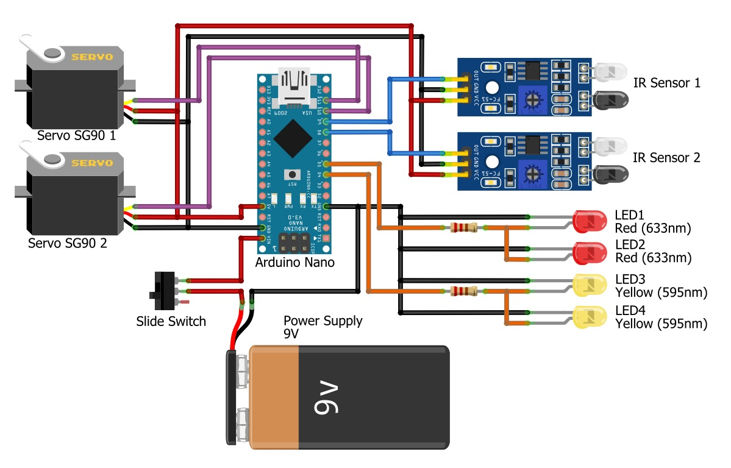

**Fig no. 4.1 Architecture diagram**

* 1. **CIRCUIT DIAGRAM**

A circuit diagram, also known as an electrical diagram, elementary diagram, or electronic schematic, is a graphical representation that simplifies an electrical circuit. It serves as a visual tool for the design, construction, and maintenance of electrical and electronic equipment.

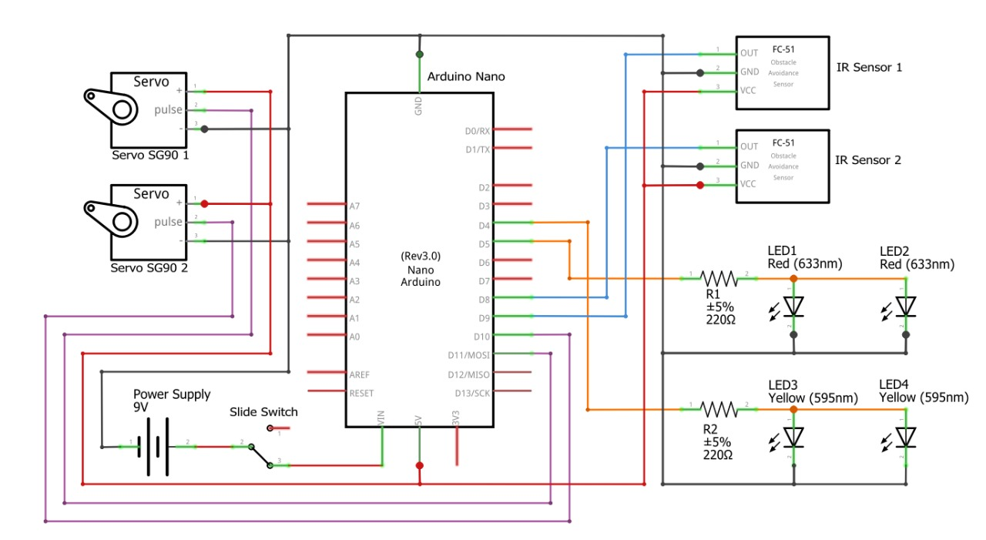

**Fig no. 4.2 Circuit diagram**

* 1. **BLOCK DIAGRAM**

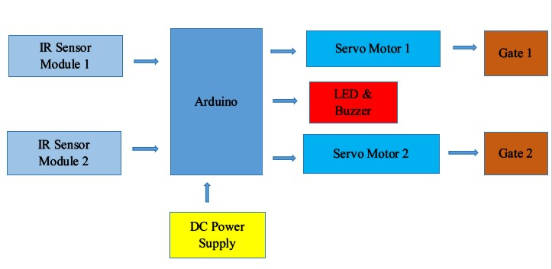

**Fig no. 4.3 Block diagram**

**4.4 FLOW CHART**

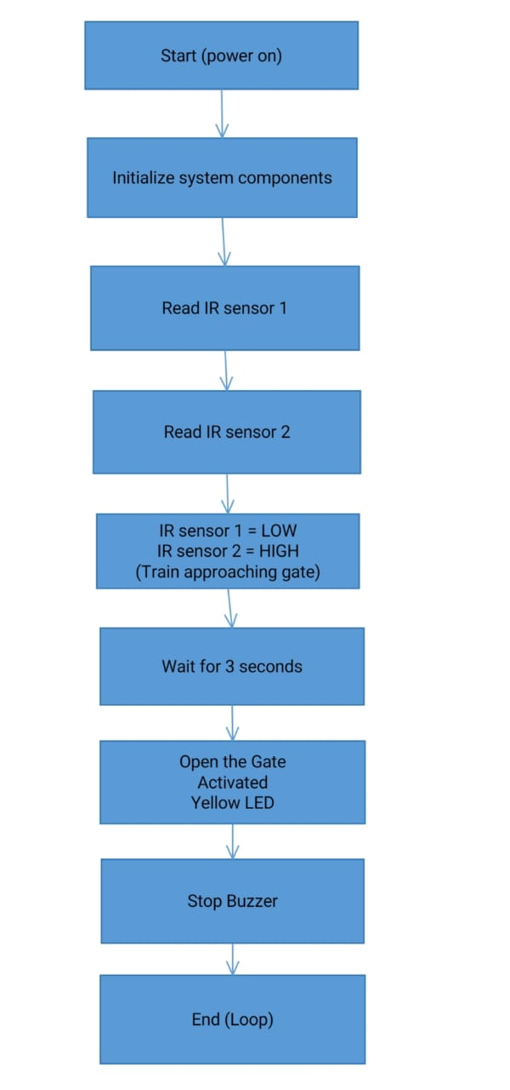

**Fig no. 4.4. Flow chart**

**4.5 UML DIAGRAM**

**4.5.1 CLASS DIAGRAM**

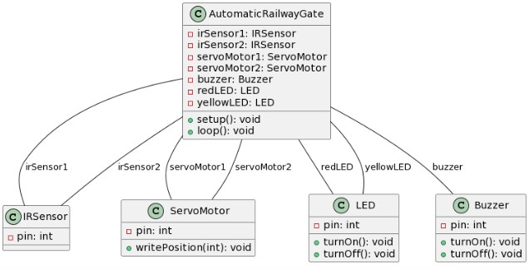

**Fig no. 4.5.1 Class diagram**

**4.5.2 ACTIVITY DIAGRAM**

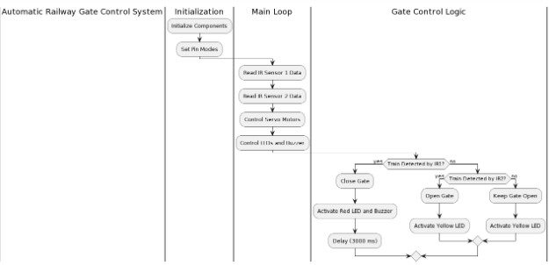

**Fig no. 4.5.2 Activity diagram**

1. **SOFTWARE AND HARDWARE REQUIREMENTS**

**5.1 HARDWARE REQUIREMENT**

**ARDUINO NANO:** Arduino Nano is a small, complete, flexible and breadboard-friendly Microcontroller board, based on ATmega328p, developed by Arduino.cc in Italy in 2008 and contains 30 male I/O headers, configured in a DIP30 style. Arduino Nano Pinout contains 14 digital pins, 8 analog Pins, 2 Reset Pins & 6 Power Pins.

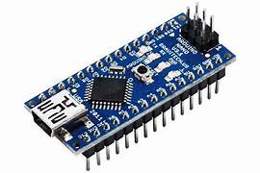

**Fig no. 5.1.1 Arduino Nano**

**SG-90 SERVO MOTOR** : SERVO MOTOR SG90 DATA SHEET Tiny and lightweight with high output power. Servo can rotate approximately 180 degrees (90 in each direction), and works just like the standard kinds but smaller. You can use any servo code, hardware or library to control these servos.

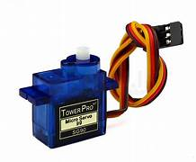

**Fig no. 5.1.2 Servo motor**

**IR SENSOR MODULE** : The IR sensor module consists mainly of the IR Transmitter and Receiver, Op-amp, Variable Resistor (Trimmer pot), output LED along with few resistors. IR LED emits light, in the range of Infrared frequency. IR light is invisible to us as its wavelength (700nm – 1mm) is much higher than the visible light range.

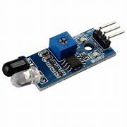

**Fig no. 5.1.3 IR sensor module**

**BUZZER** : The buzzer is an electrical device that is used to get a buzzing or beeping sound. The buzzing or beeping sound is created by vibrations developed in the diaphragm of the device. The buzzer circuit consists of a copper wire, nails, battery, an armature, and an electric buzzer.

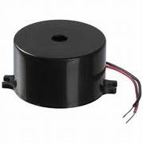

**Fig no. 5.1.4 Buzzer**

**LED** : LED stands for light-emitting diode, a semiconductor device that emits infrared or visible light when charged with an electric current.

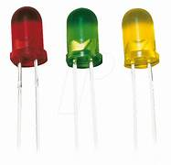

**Fig no. 5.1.5 LED**

**9V- BATTERY** : The nine-volt battery, or 9-volt battery, is an electric battery that supplies a nominal voltage of 9 volts.

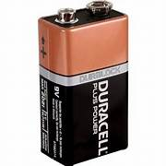

**Fig no. 5.1.6 Battery**

**TOGGLE OR SLIDE SWITCH** : An electrical switch that activates by a moving lever or a handle forward and backward to open or close an electrical switch is known as a toggle switch. These switches are also called toggle power switches or joystick switches. These switches are versatile devices, so they can be utilized with any electrical application.

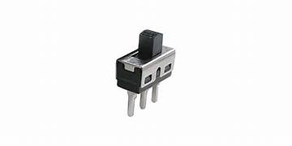

**Fig no. 5.1.7 Toggle**

**5.2 SOFTWARE REQUIREMENT**

**Arduino IDE:**

**Purpose**: The Arduino Integrated Development Environment (IDE) is essential for programming the Arduino microcontroller. It provides a user-friendly platform for writing, compiling, and uploading code to the Arduino board.

**Usage**: Write and upload the Arduino code that controls the functionality of the system, including reading data from IR sensors, managing servo motor movements, and activating LEDs and the buzzer.

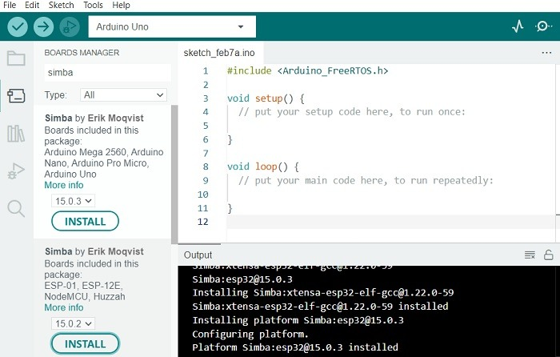

**Fig no. 5.2.1 Arduino IDE**

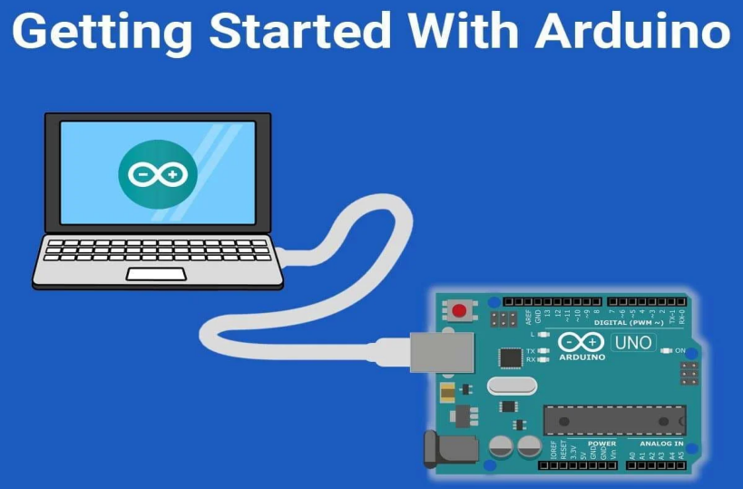

**Fig no. 5.2.2 Getting started with Arduino**

**REFERENCES**

1. M.I.M.Amjath , T.Kartheeswaran, “An Automated Railway Level Crossing System”, Department of Physical Science Vavuniya Campus of the university of Jaffina Sri Lanka, 2020 International Conference on Image Processing and Robotics (ICIP) | 978-1-7281- 6541-7/20/$31.00 ©2020 IEEE DOI:10.1109/ICIP48927.2020.9367346
2. Hongyu Zhang, zhiming Liu, Chunxiao Fan, “Study and Apllication of Integrated Monitoring System for Disaster and Accident Prevention in Railway Passenger-Dedicated Lines” |The 33rd Annual Conference of the IEEE Industrial Electronics Society (IECON) , Nov. 5-8, 2007, Taipei, Taiwan.

**3.** El-Miloudi El-Koursi and Jean-Luc Bruyelle, “Railway Accident Prevention and Infrastructure Protection”, IFSTTAR (French Institute of Science and Technology for Transport, Development and Networks), Villeneuve 59666, France. |Journal of Civil

Engineering and Architecture 10 (2016) 96-107 doi: 10.17265/19347359/2016.01.010

**4**.M.D. Anil, Sangeetha.S, Divya.B, Niranjana.B and Shruthi.K.S,,” Advanced Railway Accident Prevention System Using Sensor Networks”, TCE department, GSSSIETW, Mysore, India | International Journal of Advanced Research in Computer

and Communication Engineering Vol. 3, Issue 5, May 2014

**5.**“Protected or not, railway crossings are veritable death traps.” [Online]. Available:

http://www.sundaytimes.lk/110612/News/nws\_23.htm l. [Accessed: 05-Nov-2019].

**7.**[Arun.P,Saritha.S, K.M.Martin, Madhukumar.S “Simulation of zigbee based TACS for

collision detection and avoidance for railway traffic.,” in International conference on advanced computing & communication technologies for high performance application, paper ID 51,June 2012.

**8.**Bhatt, Ajaykumar A, „An Anti-Collision Device (ACD) Network – A train Collision Prevention System (TCPS)‟.

**9.** David Barney and George Nikandros: Calculating Train Braking Distance, Signal and Operational Systems Queensland Railways Brisbane 4001, Queensland, Australia.

**10**.Risk Analysis of Derailment Induced by Rail Breaks − a Probabilistic approach, Jianmin Zhao, University of Birmingham, Andrew H. C. Chan, Professor, University of Birmingham, Alan B. Stirling, University of Birmingham.

**11**. Masayuki Matsumoto, “The Revolution of Train Control System in JAPAN”, 2005 IEEE.